Activity – 4
Question 1 – Empirical Cumulative Distribution Function (ECDF)
Code:
# Student Quiz Marks
marks <- c(45, 52, 58, 60, 65, 68, 72, 75, 80, 90)
# Sort the marks
sorted_marks <- sort(marks)
# Number of observations
n <- length(sorted_marks)
# Calculate cumulative probabilities
cum_prob <- (1:n) / n
# Create ECDF table
ecdf_table <- data.frame(
Marks = sorted_marks,
Cumulative_Probability = cum_prob
)
# Display ECDF table
print(ecdf_table)
# Plot ECDF
plot(
ecdf(marks),
main = "Empirical Cumulative Distribution Function (ECDF)",
xlab = "Quiz Marks",
ylab = "Cumulative Probability",
verticals = TRUE,
do.points = TRUE,
col = "blue",
lwd = 2
)
grid()
Output:
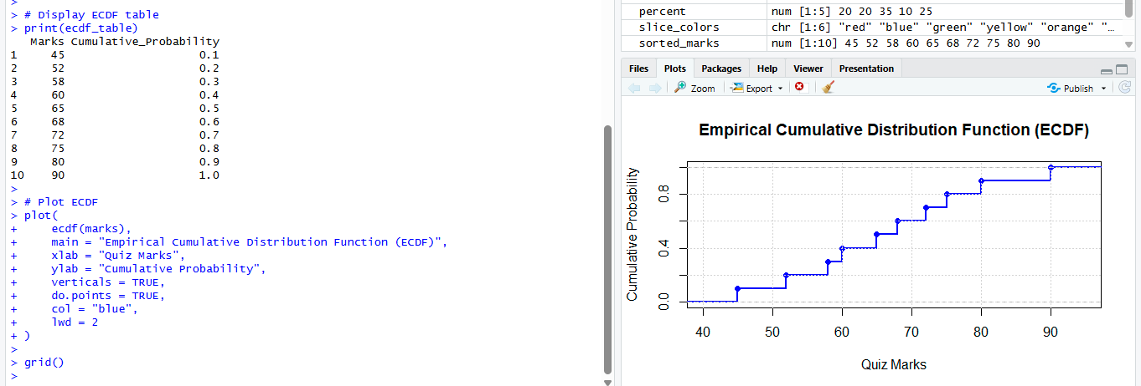
Question 2 – Empirical Cumulative Distribution Function (ECDF)
Program:
# Daily steps of participants
steps <- c(4200, 5000, 5600, 6100, 6800, 7200, 8100, 9200, 10400, 12000)
# Sort the data
sorted_steps <- sort(steps)
# Number of observations
n <- length(sorted_steps)
# Calculate cumulative probabilities
cum_prob <- (1:n) / n
# Create ECDF table
ecdf_table <- data.frame(
Daily_Steps = sorted_steps,
Cumulative_Probability = cum_prob
)
# Display ECDF table
print(ecdf_table)

# Proportion of participants with 8000 steps or fewer
ecdf_func <- ecdf(steps)
prop_8000 <- ecdf_func(8000)
cat("Proportion of participants with 8000 steps or fewer =", prop_8000, "\n")
# Plot ECDF
plot(
ecdf_func,
main = "Empirical Cumulative Distribution Function (ECDF)",
xlab = "Daily Steps",
ylab = "Cumulative Probability",
verticals = TRUE,
do.points = TRUE,
col = "blue",
lwd = 2
)

abline(v = 8000, col = "red", lty = 2)
abline(h = prop_8000, col = "darkgreen", lty = 2)
grid()
Output:
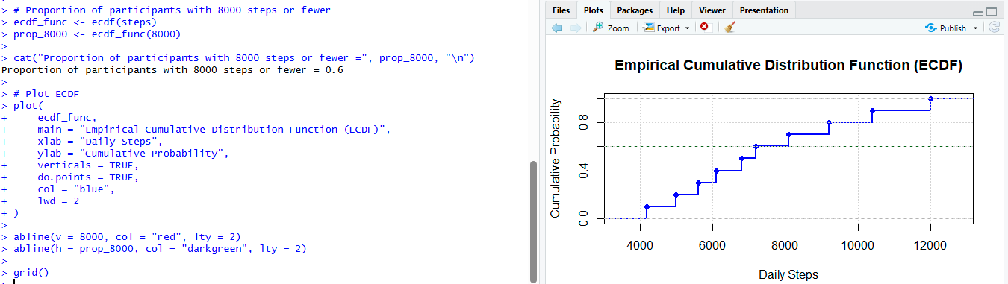

Question 3 – Highly Skewed Distribution (Histogram and Density Plot)
Program:
# Purchase Amounts
purchase <- c(250, 300, 320, 350, 380, 450, 520, 650, 1800, 5200)
# Histogram
hist(
purchase,
probability = TRUE,
main = "Histogram of Purchase Amounts",
xlab = "Purchase Amount (₹)",
col = "lightblue",
border = "black"
)
# Density Curve
lines(density(purchase), col = "red", lwd = 2)
grid()
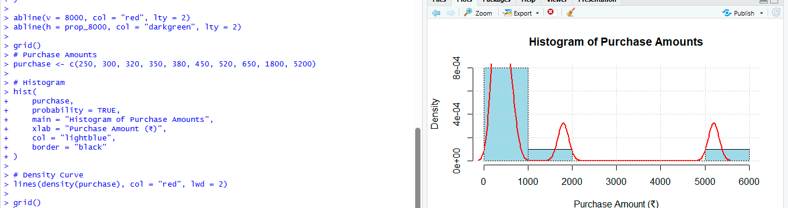

Question 4 – Quantile-Quantile (Q-Q) Plot
Program:
# Waiting Times
waiting <- c(12, 15, 18, 20, 22, 24, 25, 28, 30, 32)
# Normal Q-Q Plot
qqnorm(
waiting,
main = "Normal Q-Q Plot of Waiting Times"
)
qqline(waiting, col = "red", lwd = 2)
grid()
Output:
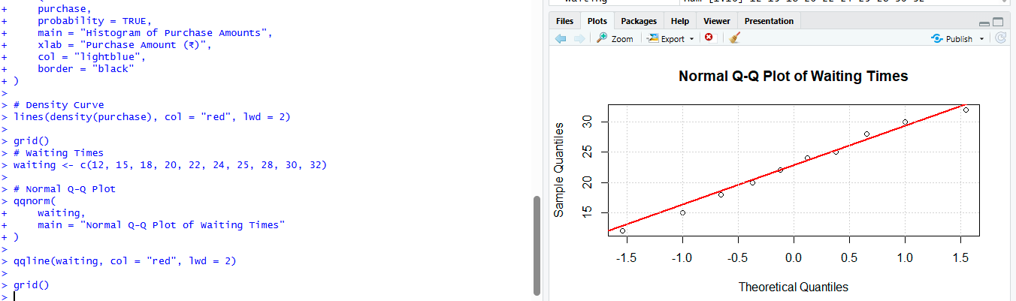
Question 5 – Highly Skewed Distribution and Q-Q Plot
Program:
# Monthly Income
income <- c(18000, 22000, 24000, 26000, 28000, 30000, 34000, 42000, 85000, 200000)

# Histogram
hist(
income,
main = "Histogram of Monthly Income",
xlab = "Monthly Income (₹)",
col = "lightgreen",
border = "black"
)

grid()
# Normal Q-Q Plot
qqnorm(
income,
main = "Normal Q-Q Plot of Monthly Income"
)
qqline(income, col = "red", lwd = 2)
grid()
Output:
